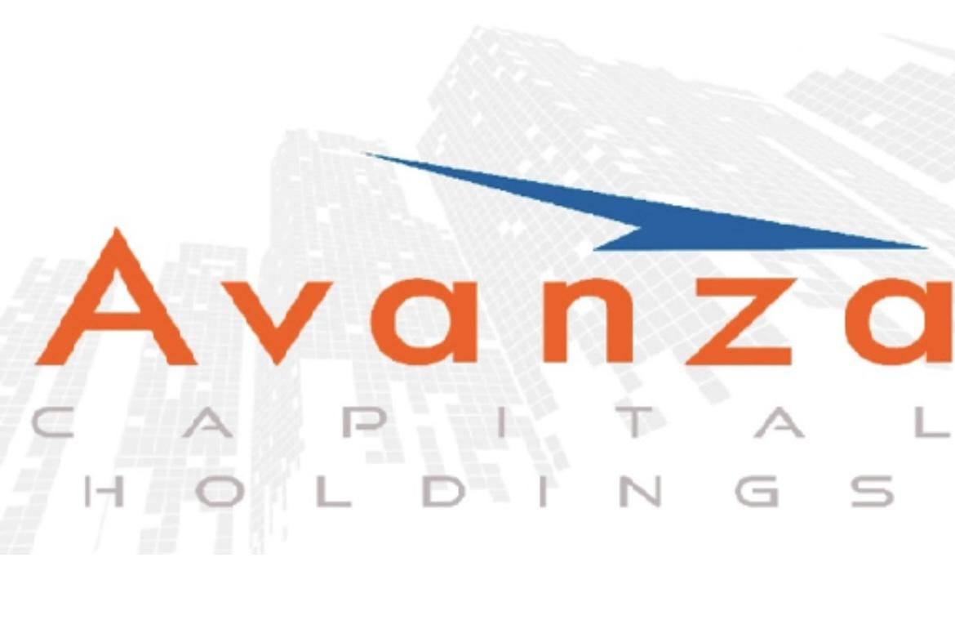**Avanza Capital’s Very Own Michael Henry Gains Momentum in Bid for New York State Attorney General**

Trusted legal strategist and commercial litigator secures 6,000+ donors as he launches high-profile rematch campaign

[April 29, 2025 | New York Post](https://nypost.com/2025/04/29/)

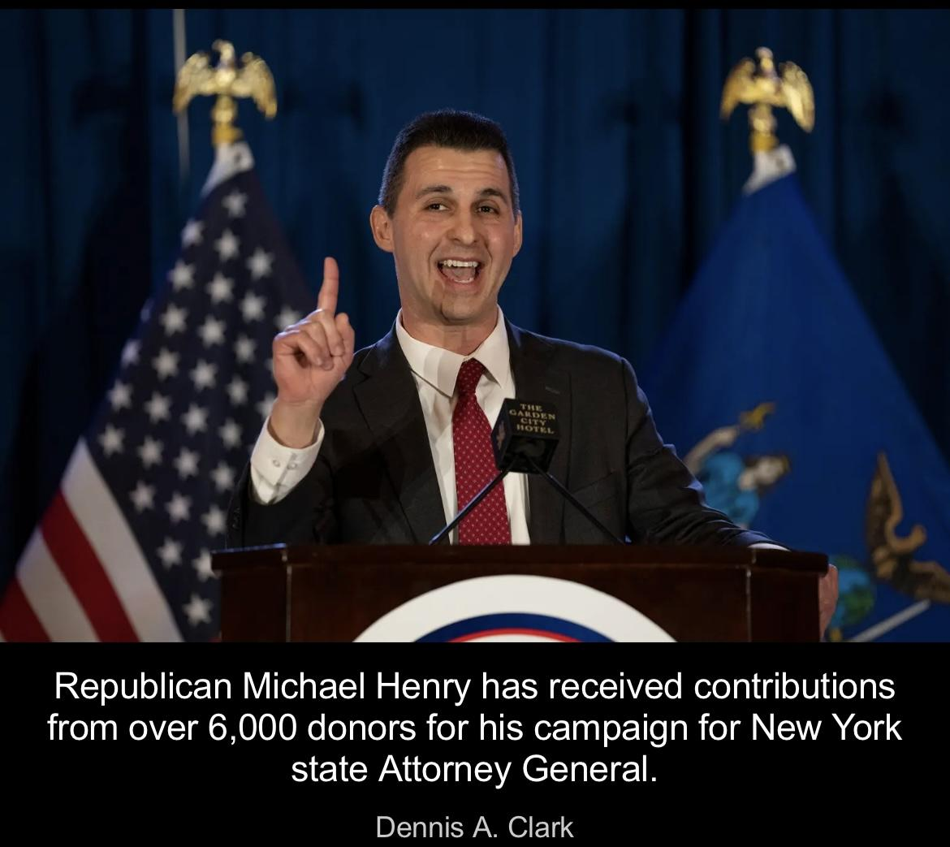

New York, NY – April 29, 2025 — Avanza Capital Holdings proudly celebrates Michael Henry, the firm’s outside legal counsel and a driving force behind its litigation and compliance strategy, as he officially launches his 2026 campaign for New York State Attorney General. With contributions from over 6,000 donors, including more than 1,200 qualifying for public matching funds, Henry’s campaign is off to a powerful and promising start.

Michael Henry has long served as a legal cornerstone for Avanza Capital Holdings, playing a key role in managing complex merchant cash advance receivables enforcement, contract remediation, and risk litigation strategies. His deep understanding of commercial litigation and creditor bankruptcy has helped solidify the firm’s leadership position in the private credit and alternative non-bank financing.

<https://www.henryforny.com/>

“This campaign is about restoring trust and accountability across New York State,” said Henry. “I’ve spent my career fighting for transparency and upholding the rule of law—and that same dedication will guide me as Attorney General.”

[America's Top 50 Lawyers](https://www.americastop50lawyers.com/)

[Avanza Capital Holdings Asserts Legal Supremacy in Private Credit ...](https://www.morningstar.com/news/accesswire/984076msn/avanza-capital-holdings-asserts-legal-supremacy-in-private-credit-with-elite-counsel)

Henry works alongside Anthony C. Varbero, General Counsel of Avanza Capital Holdings, to navigate regulatory, contractual, and litigation matters that directly impact the company’s investor returns and legal posture. Together, they ensure Avanza’s operations remain secure, compliant, and lender-first in today’s complex financial landscape.

Frank Scarso, CEO of Avanza Capital Holdings, shared his support:

“Michael is more than legal counsel—he’s a strategic partner, a trusted advocate, and a leader who embodies the values of discipline, integrity, and accountability. As he enters the next chapter of public service, we are proud to stand behind him and share in his vision for a better New York.”

Anthony DeBenedictis, Managing Partner and Chief Strategy Officer of Avanza Capital Holdings, added:

“As Managing Partner, I’m proud to communicate this exciting milestone to our valued lending partners, clients, and stakeholders. Michael’s campaign reflects the very principles that drive our business—transparency, accountability, and a commitment to doing what’s right, even when it’s not easy. His leadership continues to inspire confidence within our firm and the overall broader community.”

In addition to his legal credentials, Henry has a record of recovering millions for clients, representing asylum seekers, and working on complex legal issues—bringing a multifaceted perspective to both public service and private enterprise. His campaign platform is laser-focused on public safety, government transparency, and COVID-era accountability—principles that closely align with the operational ethos of Avanza Capital Holdings.

About Avanza Capital Holdings

<https://avanza.nyc/about-us/>

Avanza Capital Holdings is a non-traditional private fixed-income platform specializing in short-term, collateral-backed business financing for companies underserved by traditional lenders. Offering 20% annualized returns with monthly distributions of principal and interest, the platform maintains a disciplined portfolio approach supported by robust legal oversight and risk management. Accredited lenders gain access to a diverse portfolio with high liquidity, moderate risk, and consistent performance.

Media Contact

https://avanza.nyc/

40 Wall Street, New York, NY 28th Fl 10005  
Avanza Capital Holdings

Frank Scarso  
CEO  
frank@avanza.nyc  
212-320-0532

Anthony DeBenedictis  
Managing Partner/Chief Strategic Officer  
anthony@avanza.nyc  
914-536-7565

[https://avanza.nyc/in-the-news/](https://pr.report/74aq)

Disclaimer

This press release is for informational purposes only and does not constitute an offer to sell or a solicitation of an offer to buy any securities, financial instruments, or investment advisory services. Past performance is not indicative of future results, and no guarantees of returns are made. Avanza Capital Holdings is not a registered investment advisor, Hedge fund or SEC filing and nothing in this release should be construed as financial, legal, or tax advice. Prospective lenders should conduct their own due diligence and consult with independent legal and financial professionals before participating as an accredited lending partner. The outside general counsel for Avanza Capital Holdings provides legal oversight and regulatory guidance and is not responsible for the overall activity, actions, or financial outcomes in connection with the business relationships between Avanza Capital and its respective lending partners. General counsel conducts legal services as an outside entity to and for Avanza Capital Holdings and is not directly employed by Avanza Capital and acts solely as "Outside General Counsel."

